**AIM:**  Design DFA using simulator to accept the input string “bc” ,”c”,and ”bcaaa

**INPUT:**

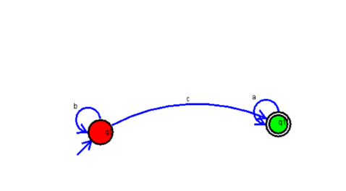

**OUTPUT:**

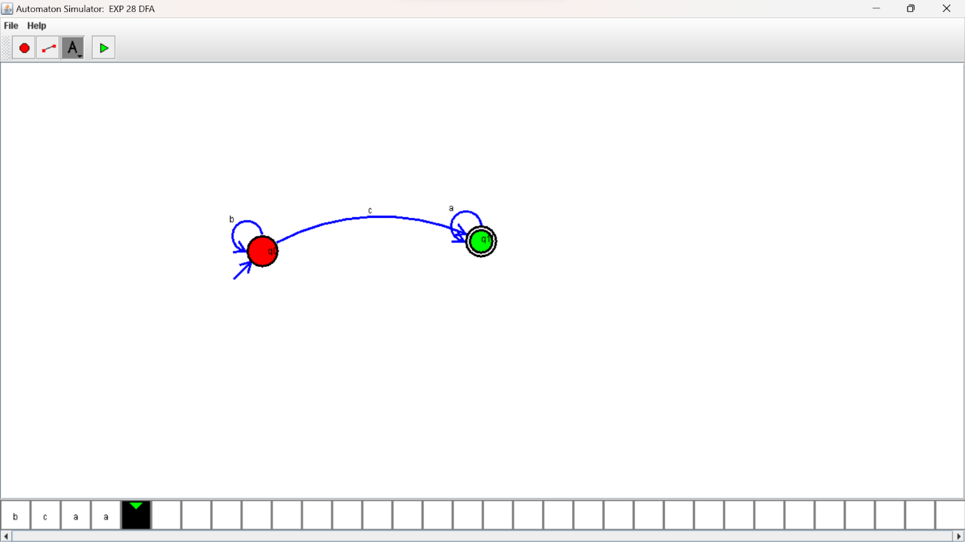

**RESULTS:**

Design DFA using simulator to accept the input string “bc” ,”c”,and ”bcaaa